13.07.2023

**React shopping cart application test report:**

Application address: https://react-shopping-cart-67954.firebaseapp.com

**ASSUMPTIONS FOR TESTING:**

Tester: Pawel Panek / https://github.com/PanekPawel

Date and time of test execution: 06.07.2023 from 8:00 am to 4:00 pm

Environment: Windows 10 64-bit, Mozilla Firefox version: 115.0.2

**Characteristics of the tested application:**

React-shopping-cart is an application that allows you to buy clothes without creating an account**.**

**Tools used:**

TestRail - test cases

Jira - bug report

Google Lighthouse - website audit

Selenium IDE- exploratory testing

**APPLICATION ELEMENTS TESTED:**

1.Availability of products on the home page - OPERATIVE ( with a significant defect).

2.Size filters - OPERATES ACCORDING TO SPECIFICATIONS.

3.Operation of the shopping cart - OPERATES ACCORDING TO SPECIFICATIONS.

**DEFECTS:**

ID - 01

According to the specification, 16 types of shirts should be displayed on the home page. The page displays 15 types of shirts and one sweatshirt

Weight of the error: significant

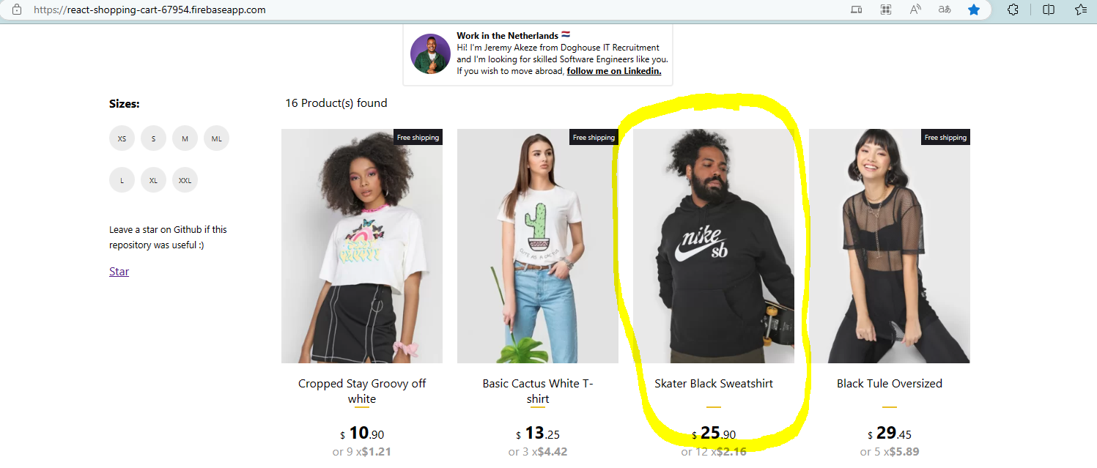

**SUMMARY :**

I managed to test the assumptions contained in the specification

My limitation was time ( free trial on TestRail).

The display of products on the home page needs improvement,

Other than that, the site works fine.